Title
Application of the Substitution Method to Analyze a Digital Library Search Engine

Aim
To solve the recurrence relation
T(n)=T(n−1)+log⁡nT(n)=T(n-1)+\log nT(n)=T(n−1)+logn
using the substitution method and determine its time complexity.

Problem Statement
A digital library stores thousands of books and research papers. When a user searches for a document, the system processes the search according to the recurrence relation
T(n)=T(n−1)+log⁡nT(n)=T(n-1)+\log nT(n)=T(n−1)+logn
where
- nnn = number of documents
- T(n)T(n)T(n) = total search processing time
The objective is to solve the recurrence using the substitution method and determine its asymptotic complexity.

Algorithm
- Read the number of documents nnn.
- Use recursion to compute
T(n)=T(n−1)+log⁡nT(n)=T(n-1)+\log nT(n)=T(n−1)+logn
- Expand the recurrence.
- Simplify the summation.
- Apply Stirling's Approximation.
- Determine the asymptotic complexity.

Source Code
import math
def T(n):
if n == 1:
return 1
return T(n - 1) + math.log2(n)
print("========================================")
print(" DIGITAL LIBRARY SEARCH ENGINE")
print("========================================")
print("Recurrence Relation: T(n) = T(n-1) + log2(n)\n")
n = int(input("Enter the number of documents (n): "))
print("\nSubstitution Expansion")
print("----------------------------------------")
print("T(n) = T(n-1) + log2(n)")
print(" = T(n-2) + log2(n-1) + log2(n)")
print(" = T(n-3) + log2(n-2) + log2(n-1) + log2(n)")
print(" = ...")
print(" = T(1) + log2(2) + log2(3) + ... + log2(n)")
print(" = T(1) + log2(n!)")
result = T(n)
print("\nResult")
print("----------------------------------------")
print(f"T({n}) = {result:.4f}")
print("\nPerformance Analysis")
print("----------------------------------------")
print("As n increases, each new document adds")
print("only log2(n) additional processing time.")
print("The accumulated cost becomes log2(n!).")
print("Using Stirling's Approximation:")
print("log(n!) = Θ(n log n)")
print("Therefore,")
print("T(n) = Θ(n log n)")

Output
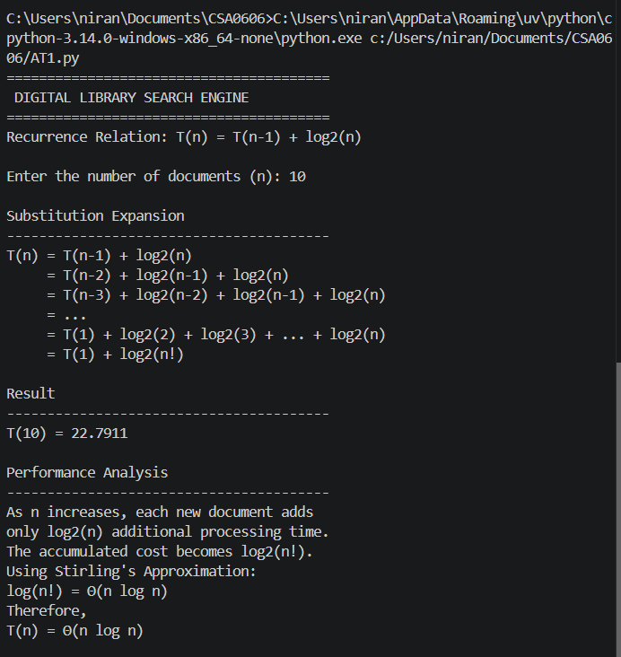

Step-by-Step Solution (Substitution Method)
Given,
T(n)=T(n−1)+log⁡nT(n)=T(n-1)+\log nT(n)=T(n−1)+logn

Step 1
Expand once:
T(n)=T(n−2)+log⁡(n−1)+log⁡nT(n)=T(n-2)+\log(n-1)+\log nT(n)=T(n−2)+log(n−1)+logn

Step 2
Expand again:
T(n)=T(n−3)+log⁡(n−2)+log⁡(n−1)+log⁡nT(n)=T(n-3)+\log(n-2)+\log(n-1)+\log nT(n)=T(n−3)+log(n−2)+log(n−1)+logn

Step 3
Continue expanding:
T(n)=T(1)+log⁡2+log⁡3+⋯+log⁡nT(n)=T(1)+\log2+\log3+\cdots+\log nT(n)=T(1)+log2+log3+⋯+logn

Step 4
Using the logarithm property,
log⁡a+log⁡b=log⁡(ab)\log a+\log b=\log(ab)loga+logb=log(ab)
Therefore,
T(n)=T(1)+log⁡(2×3×4⋯n)T(n)=T(1)+\log(2\times3\times4\cdots n)T(n)=T(1)+log(2×3×4⋯n)
Since
2×3×4⋯n=n!2\times3\times4\cdots n=n!2×3×4⋯n=n!
we get
T(n)=T(1)+log⁡(n!)T(n)=T(1)+\log(n!)T(n)=T(1)+log(n!)

Step 5
Using Stirling's Approximation,
n!≈2πn(ne)nn!\approx\sqrt{2\pi n}\left(\frac{n}{e}\right)^nn!≈2πn​(en​)n
Taking logarithms,
log⁡(n!)=Θ(nlog⁡n)\log(n!)=\Theta(n\log n)log(n!)=Θ(nlogn)
Therefore,
T(n)=Θ(nlog⁡n)\boxed{T(n)=\Theta(n\log n)}T(n)=Θ(nlogn)​

Analysis
- Each additional document contributes only log⁡n\log nlogn extra work.
- Although logarithmic growth is slow, the cumulative cost across all documents is log⁡(n!)\log(n!)log(n!).
- Applying Stirling's Approximation shows that the total growth rate is Θ(nlog⁡n)\Theta(n\log n)Θ(nlogn).
- This indicates the search engine scales efficiently for large digital libraries compared to quadratic algorithms.

Asymptotic Notation
Notation | Complexity
Best Case | Ω(n log n)
Average Case | Θ(n log n)
Worst Case | O(n log n)
Since all three bounds are the same, the recurrence is classified as
Θ(nlog⁡n)\boxed{\Theta(n\log n)}Θ(nlogn)​

Conclusion
The recurrence relation T(n)=T(n−1)+log⁡nT(n)=T(n-1)+\log nT(n)=T(n−1)+logn was solved using the substitution method. By expanding the recurrence and simplifying the logarithmic summation to log⁡(n!)\log(n!)log(n!), then applying Stirling's Approximation, the final time complexity is obtained as Θ(nlog⁡n)\Theta(n\log n)Θ(nlogn). This means the digital library search engine's processing time grows proportionally to nlog⁡nn\log nnlogn, making it efficient and scalable as the number of documents increases.

